BO’SH O’ZLASHTIRUVCHILAR BILAN ISHLASH
REJASI
T/r | Qilinadigan ishlar mazmuni | Muddati | Mas’ul shaxs
1 | Alohida suhbat o’tkazish orqali ulgurmaslik sababini aniqlash | Har kuni | Fan o`qituvchilari
2 | A’lochi o’quvchilarga biriktirish | Oktabr | Fan o`qituvchilari
3 | Qo’shimcha topshiriq berish | Bo’sh vaqtda | Fan o`qituvchilari
4 | Darslarda alohida-alohida topshiriq berish | Darsda | Fan o`qituvchilari
5 | O’zlari qiziqqan yo’nalish bo’yicha topshiriq berish | Yil davomida | Fan o`qituvchilari
6 | Test orqali o’quvchilar bilimidagi bo’shliqni to’ldirish | Har chorakda | Fan o`qituvchilari

BO’SH O’ZLASHTIRUVCHI O’QUVCHILAR HAQIDA MA’LUMOT
T/r | F.I.SH | Sinfi | Tug’ilgan sana | Manzili
1
2
3
4
5
6
7
8
9
10
11
12
13
14
15
16
17
18
19
20
21
22

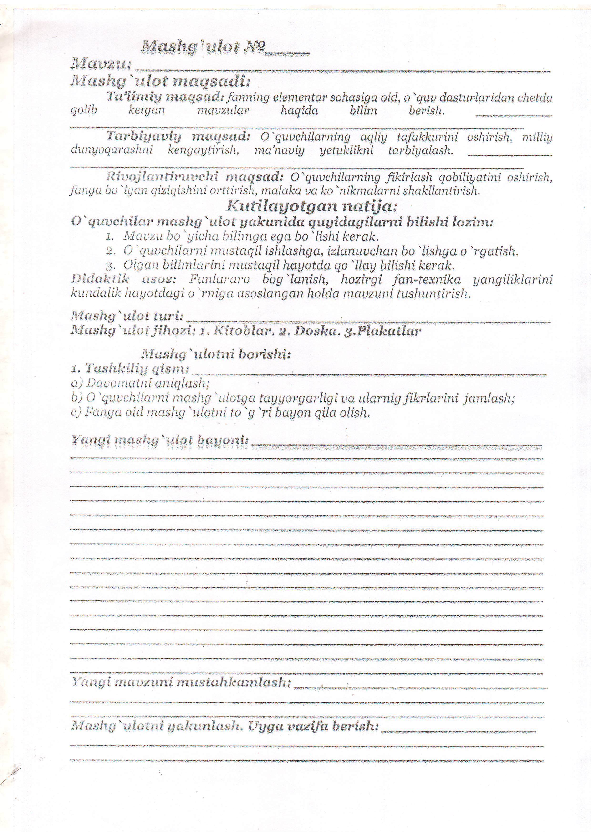

BO’SH O’ZLASHTIRUVCHI O’QUVCHILAR SAMARADORLIGI
T/r | F.I.SH | Sinfi | I chorak |  |  |  |  |  |  |  |  |  | Farqi + -
 |  |  | Chorak boshida samaradorlik |  |  |  |  |  |  |  |  | Chorak oxirida samaradorlik
1
2
3
4
5
6
7
8
9
10
11
12
13
14
15
16
17
18
19
20
21
22

BO’SH O’ZLASHTIRUVCHI O’QUVCHILAR SAMARADORLIGI
T/r | F.I.SH | Sinfi | II chorak |  |  |  |  |  |  |  |  |  | Farqi + -
 |  |  | Chorak boshida samaradorlik |  |  |  |  |  |  |  |  | Chorak oxirida samaradorlik
1
2
3
4
5
6
7
8
9
10
11
12
13
14
15
16
17
18
19
20
21
22

BO’SH O’ZLASHTIRUVCHI O’QUVCHILAR SAMARADORLIGI
T/r | F.I.SH | Sinfi | III chorak |  |  |  |  |  |  |  |  |  | Farqi + -
 |  |  | Chorak boshida samaradorlik |  |  |  |  |  |  |  |  | Chorak oxirida samaradorlik
1
2
3
4
5
6
7
8
9
10
11
12
13
14
15
16
17
18
19
20
21
22

BO’SH O’ZLASHTIRUVCHI O’QUVCHILAR SAMARADORLIGI
T/r | F.I.SH | Sinfi | IV chorak |  |  |  |  |  |  |  |  |  | Farqi + -
 |  |  | Chorak boshida samaradorlik |  |  |  |  |  |  |  |  | Chorak oxirida samaradorlik
1
2
3
4
5
6
7
8
9
10
11
12
13
14
15
16
17
18
19
20
21
22

O’tilgan mashg’ulotlar
№ | O’quvchilarning ismi - sharifi |  |  |  |  |  |  |  |  |  |  |  |  |  |  |  |  |  | Sana | Mavzular
1
2
3
4
5
6
7
8
9
10
11
12
13
14
15
16
17
18
19
20
21
22
23
24
25
26

