Subject: ENGLISH
Teacher: ISMOILOVA MEHRIBON
Date:
Time: 45 min
Theme: My favourite hobby is…
Aim: Educational: to practise talking about leisure activities.
Upbringing: to practise listening for spesific information.
Developing: to practise talking about the most popular and least popular
activities.
Handouts: a textbook, pictures,dictionary.
The type: giving new knowledge.
The method: conversational, groupwork.
Procedure: 1.Greeting. 3 min
2.Reinforce the learnt material. 8 min
3.Explain the new theme. 18 min
4.Consolidation. 10 min
5.Evaluating pupils. 4 min
6.Homework. 2min
Warm up: Good morning! Are all the pupils present today? What season is it now? What is the weather like today? Play: I am …use adjectives.
The previous lesson was adjectives and degrees.Ask pupils to say the degrees
of the following adjectives :
good happy dangerous
famous much outstanding
little comfortable narrow
Pupils make up sentences using these adjectives. After revising adjectives, the teacher explains the new theme.
Activity 1.Objectives: to revise vocabulary from the 5th form.
To introduce and practise some new words.

Listening to music

Watching TV
Writing poems

Collecting coins
Sewing

Fishing
Growing flowers

Drawing pictures

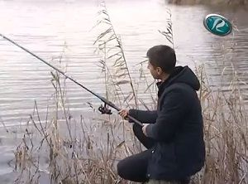
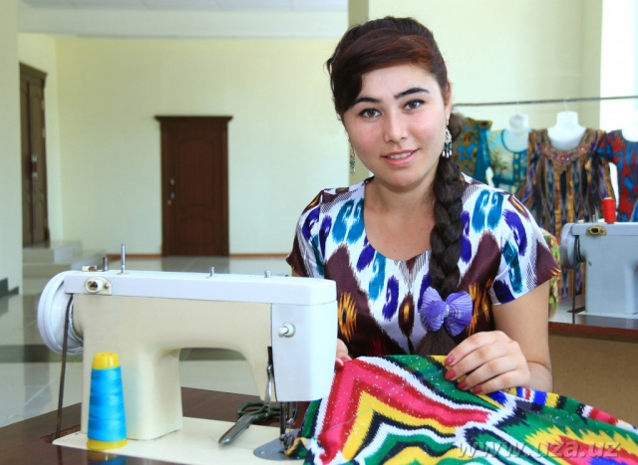
Fishing Sewing

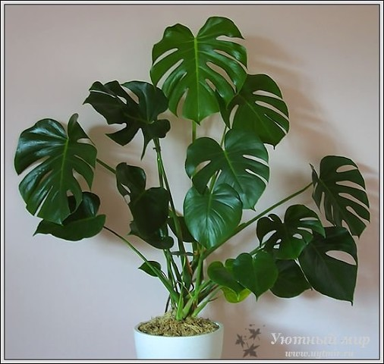
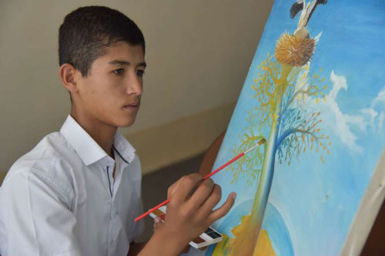
Drawing pictures
Growing flowers

Watching TV

Activity 2.Objective: to practice listening for specific information .Pupils listen to the tape and guess the answers. The teacher checks their answers.
Answer key: 1 b , 2 b ,3 c.
Activity 3.Objectives: to practise reading information in tables.
to practise talking about most popular and least popular activities using the superlatives.

Consddation:
1.Mу hobbу is ….
A) Collect coins B) Collecting coins C) Coins.
2. Malik likes collecting….
A) caps B) poems C) stamps.
3.Boуs like….
A) watching TV B) collect s tamps C) fish.
4. Growing flowers …. useful.
A) is B) isn’t C) are.
5. Is уour hobbу…..?
A) draw pictures B) drawing pictures C) pictures.

1.Evaluating pupils.
2.Homework. Ex 4.

